Alver Valley Federation of Infant Nursery and Junior Schools

Infant & Nursery School Admissions Policy 2022-23

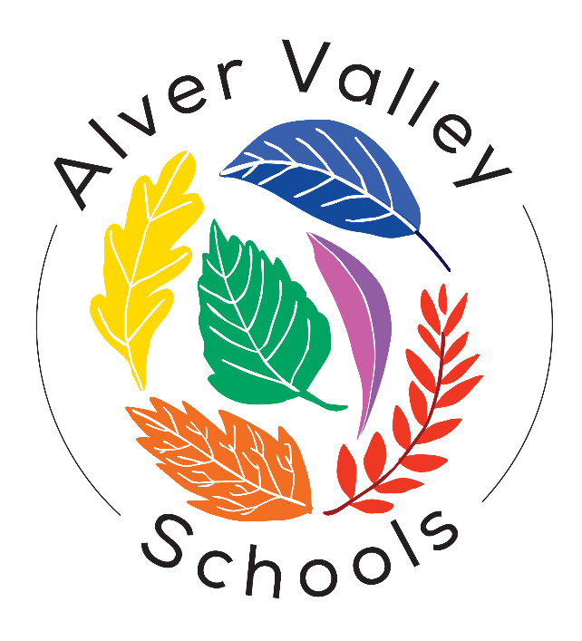

Date written | March 2021
Date approved by FGB
Review Date | N/A
Author | Hampshire Admissions

Alver Valley Infant and Nursery School
Admission Policy 2022-2023

This policy will be used during 2021/2022 for allocating places in the main admission round for entry to Year R in September 2022. It will also apply to in-year admissions during 2022/23. It does not apply to those being admitted to nursery provision.

Hampshire County Council is the admission authority for Alver Valley Infant School. The admission arrangements are determined by the County Council, after statutory consultations.

Published Admission Number (PAN)

Each school has a published admission number (PAN) for entry to Year R. The school will admit this number of children if there are sufficient applications. Where there are fewer applications than the published admission number, places will be offered to all applicants.

The PAN for Alver Valley Infant School for 2022-2023 is 60.

Admissions Process

The County Council will consider first all those applications received by the published deadline of midnight on 15 January 2022. Notifications to parents offering a primary or infant school place will be sent by the County Council on 19 April 2022.

Applications made after the deadline will be considered after all on-time applications have been fully processed unless exceptional circumstances merit consideration alongside on-time applications.

For the normal admission round, all on time preferences will be considered simultaneously and ranked in accordance with the admission criteria. If more than one school can offer a place, the parent’s highest stated available preference will be allocated.

Pupils with an Education, Health and Care Plan

Any child with an Education, Health and Care Plan naming Alver Valley Infant School will be admitted. Where possible such children will be admitted within the PAN.

Oversubscription criteria

When the school is oversubscribed, after the admission of pupils with an Education, Health and Care plan naming the school, priority for admission will be given to children in the following order:

1. Looked after children or children who were previously looked after (see definition i).

2. (For applications in the normal admission round only) Children or families with an exceptional medical and/or social need (see definition ii). Supporting evidence from a professional is required such as a doctor and/or consultant for medical needs or a social worker, health visitor, housing officer, the police or probation officer for social needs. This evidence must confirm the child or family’s medical or social need and why that need(s) makes it essential that the child attends Alver Valley Infant School rather than any other. If evidence is not submitted by the application deadline, the medical and/or social need cannot be considered.

3. Children of staff (see definition iii) who have, (1) been employed at Alver Valley Infant School for two or more years at the time at which the application for admission to the school is made, or (2) have been recruited to fill a vacant post for which there is a demonstrable skill shortage.

4. Children living in the catchment area (see definition iv) of Alver Valley Infant School who at the time of application have a sibling (see definition v) on the roll of Alver Valley Infant School or the linked junior school, Alver Valley Junior School, who will still be on roll at the time of admission. [See 6 for additional children who may be considered under this criterion.]

5. Other children living in the catchment area of Alver Valley Infant School.

6. Children living out of the catchment area of Alver Valley Infant School who at the time of application have a sibling (see definition v) on the roll of Alver Valley Infant School or the linked junior school, Alver Valley Junior School, who will still be on roll at the time of admission. [Where a sibling was allocated a place at Alver Valley Infant School or the linked junior school, Alver Valley Junior School, in the normal admission round in a previous year because the child was displaced (see definition vi) from the catchment school for their address, the application will be considered under 4, above, subject to the siblings still living in the catchment area for the school from which they were displaced. In future normal admissions rounds a younger sibling will be considered to have been displaced where they were allocated a place at Alver Valley Infant School or the linked junior school, Alver Valley Junior School, under this criterion as a consequence of their elder sibling’s displacement and are still living in the catchment area for the school from which they were displaced].

7. Out of catchment children attending the on-site, school run nursery, have priority over other out-catchment children [school specific criterion].

8. Other children.

Definitions
(i) Looked after children are defined as those who are (a) in the care of a local authority, or (b) being provided with accommodation by a local authority in the exercise of their social services functions (see the definition in section 22(1) of the Children Act 1989). Previously looked after children are those who were looked after but immediately after being looked after became subject to an adoption order, child arrangements order, or special guardianship order. An adoption order is an order under section 46 of the Adoption and Children Act 2002 or section 12 of the Adoption Act 1976. Child arrangements orders are defined in section 8 of the Children Act 1989, as amended by section 12 of the Children and Families Act 2014. Child arrangements orders replace residence orders and any residence order in force prior to 22 April 2014 is deemed to be a child arrangements order. Section 14A of the Children Act 1989 defines a ‘special guardianship order’ as an order appointing one or more individuals to be a child’s special guardian (or special guardians).

(ii) Applicants will only be considered under this criterion if on the application form (online or paper) they have ticked the appropriate box explicitly indicating that they wish for their application to be considered under medical / social need. ‘Medical need’ does not include mild medical conditions, such as asthma or allergies. ‘Social need’ does not include a parent’s wish that a child attends the school because of a child’s aptitude or ability or because their friends attend the school or because of routine childminding arrangements. Priority will be given to those children whose evidence establishes that they have a demonstrable and significant need to attend a particular school. Equally this priority will apply to children whose evidence establishes that a family member’s physical or mental health or social needs mean that they have a demonstrable and significant need to attend a particular school. Evidence must confirm the circumstances of the case and must set out why the child should attend a particular school and why no other school could meet the child’s needs. Providing evidence does not guarantee that a child will be given priority at a particular school and in each case a decision will be made based on the merits of the case and whether the evidence demonstrates that a placement should be made at one particular school above any other.

(iii) ‘Staff’ includes all those on the payroll of Alver Valley Infant School who (specific to clause (1)) have been an employee continuously for two years at the time of application. ‘Children of staff’ refers to situations where the staff member is the natural parent, the legal guardian or a resident step parent.

(iv) A map of the school’s catchment area is available on the school’s details page of the Hampshire County Council website www.hants.gov.uk/educationandlearning/findaschool.

(v) ‘Sibling’ refers to brother or sister, half brother or half sister, adoptive brother or adoptive sister, foster brother or foster sister, step brother or step sister living as one family unit at the same address. It will also be applied to situations where a full, half or adopted brother or sister are living at separate addresses. Criteria 4 and 6 include children who at the time of application have a sibling for whom the offer of a place at Alver Valley Infant School or the linked junior school, Alver Valley Junior School, has been accepted, even if the sibling is not yet attending. It also includes, in the normal admissions round, children who have a sibling on roll in Year 2 at Alver Valley Infant School at the time of application, who are successful in gaining a place at the linked junior school, Alver Valley Junior School, on the national notification date.

(vi) ‘Displaced’ refers to a child who was refused a place at the catchment school in the normal admissions round having named it in the application and was not offered a higher named preference school.

Tie-breaker
If the school is oversubscribed from within any of the above categories, straight line distance will be used to prioritise applications; applicants living nearer the school have priority. Distances will be measured from the Ordnance Survey home address point to the school address point using Hampshire County Council’s Geographic Information Systems (GIS). Distances to multiple dwellings will give priority to the ground floor over the first floor and so on. On individual floors, distances will be measured to the stairs leading to the communal entrance. Where two or more applicants are equidistant, random allocation will be used to allocate the place. An explanation of the random allocation procedure is available on the County website. This method of prioritising admissions will also apply to any ‘school specific’ criterion unless otherwise stated in the school's brochure.

Additional Information

Permanent Residence
The child’s permanent residence is where they live, normally including weekends and during school holidays as well as during the week, and should be used for the application. The permanent address of children who spend part of their week with one parent and part with the other, at different addresses, will be the address at which they spend most of their time.

Multiple births
Where a twin or child from a multiple birth is offered the last place available within the PAN, any further twin or child of the same multiple birth will also be offered a place, if the parents so wish, even though this may raise the number in the year group above the school’s PAN.

Fair Access placements by the local authority
Outside the normal admission round, it may sometimes be necessary for a pupil to be placed by the local authority, or a local placement panel acting on behalf of the authority, in a particular school even if there is a waiting list for admission. Such placements will be made in accordance with Hampshire County Council’s Fair Access Protocol. The Protocol is based on legislation and government guidance.

Waiting lists
Waiting lists will be established for each year group where more applications are received than places available. For main round admissions to Year R, the waiting list will be maintained centrally by the local authority until 31 August 2022. At all other times, and for other year groups, waiting lists will be operated by schools on behalf of the local authority.

Any places that become available will be offered to the child at the top of the list on the day the place became available. The waiting list is ordered according to the criteria of the admission policy with no account being taken of the length of time on the waiting list or any priority order expressed as part of the main admission round. Fair Access admissions and school closure arrangements will take priority over the waiting list.

The waiting list will be reviewed and revised –
- each time a child is added to, or removed from, the waiting list;
- when a child’s changed circumstances affect their priority;

For entry to Year R, the waiting list will remain open until 31 August 2023, at which point all names will be removed. For all other year groups, waiting lists will remain open until 31 August of each year. Parents who want their child to be considered for a place at the school in the following school year must submit a new in-year application in the August preceding the new school year. Schools will send a decision letter within the first 10 days of the new term.

Starting school
Pupils born between 1 September 2017 and 31 August 2018 (inclusive) are entitled to full-time schooling from September 2022. Parents can choose to defer their child’s admission until later in the school year (but not beyond the start of the term after they reach compulsory school age). Children can also attend part-time until they reach compulsory school age. Parents must discuss their child’s starting arrangements with the school once an offer has been secured.

Children with birthdays between:
- 1 September and 31 December 2017 (inclusive) reach compulsory school age on 31 December 2022, at the start of the spring term 2023.
- 1 January and 31 March 2018 (inclusive) reach compulsory school age on 31 March 2023, at the start of the summer term 2023.
- 1 April and 31 August 2018 (inclusive) reach compulsory school age on 31 August 2023, at the start of the new school year in September 2023.
Parents of summer born children (those born between 1 April and 31 August) who are particularly concerned about their child’s readiness for school can request to delay their child’s entry to Year R for an entire school year until September 2023. This is called decelerated admission. In making such a request, parents would be expected to state clearly why they felt decelerated admission to Year R was in their child’s best interests. It is recommended that parents considering such a request contact the local authority in the autumn term 2021 to ensure that an informed decision is made. Guidance on decelerated admission for summer born children, including how to make a request, is available on the County website at www.hants.gov.uk/ad-summerborn.

Admission of children outside their normal age group
Parents may request that their child is admitted outside their normal age group. To do so, parents should include a request with their application, specifying why admission outside the normal age group is being requested and which year group they wish their child to be admitted. Decisions will be made based on the circumstances of the case and in the best interests of the child.

School specific criteria
Governing bodies may apply to the Director of Children’s Services to include in their school policy a criterion which they regard as essential if children are to be treated fairly in relation to clearly defined local conditions. The application will cover both the substance of the criterion and its position in the order of priorities. In the event of such applications, the Director of Children’s Services will consult the Admission Forum and the criterion will then be determined by the Executive Lead Member for Children’s Services. Any criterion agreed under this category must be published in the school prospectus with its position within the admission priorities clearly indicated. It must be made clear that the criterion is school-specific. Alver Valley Infant School has one such criterion (oversubscription criterion 7; Out-catchment children attending the on-site, school run nursery have priority over other out-catchment children).

School Closures
In the event of a school closure, pupils from the closing school may be given priority for any school nominated as the receiving school. Specific arrangements will be determined by the Local Authority in accordance with the School Admissions Code and will be published at the time for the specific schools affected.

Legislation
This policy takes account of all Equalities legislation, together with all relevant regulations and the School Admissions Code (published by the DfE in 2014).

The PAN applies to the relevant year* only. For other year groups at the school, different admission limits may be applied. Please ask the school or local authority for details. * The relevant year is the age group at which pupils are or will normally be admitted to the school i.e. reception, year 3, year 7 and year 12 where the school admits external applicants to the sixth form (Section 142 of the SSFA 1998).

